# Types of Machine Learning Systems

Following are different type of ML Systems classify broad based on categories:

→ Whether or not they are trained under human supervision { supervised, unsupervised, semi supervised and reinforcement learning }

→Whether or not they can learn incrementally to fly {online vs batch learning }

→Whether they work by simply comparing new data examples with known data examples { instance-based vs model-based learning}

These classification is not exclusive, you can combine them in any way you like. Let’s look at each of them one by one.

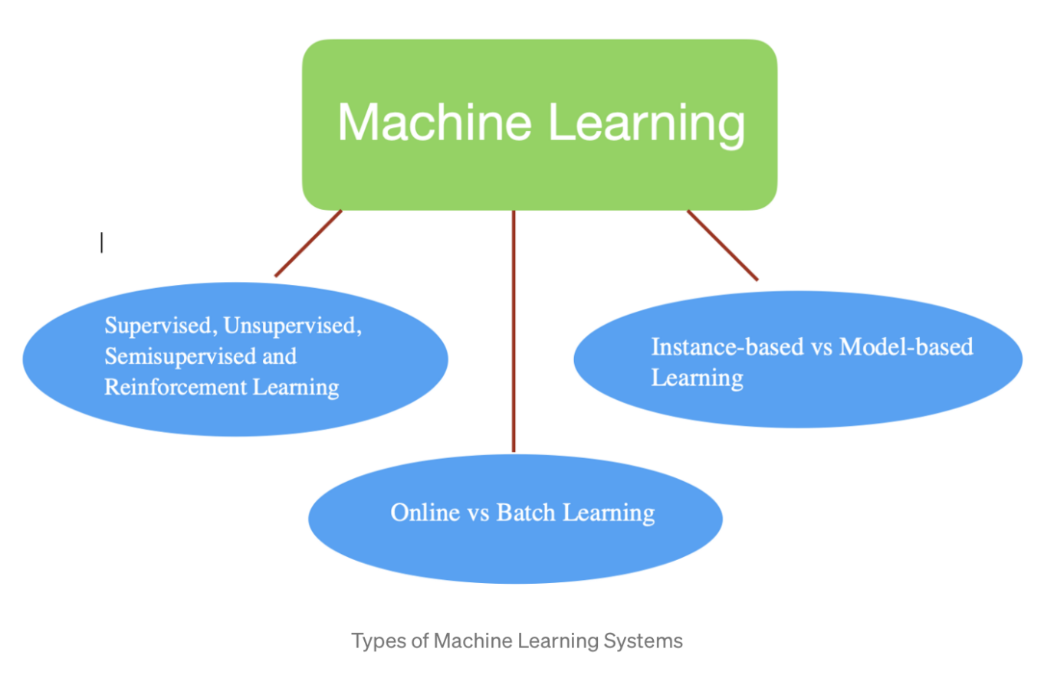

## ****Supervised Learning :-****

→ In supervised learning, training set that we feed to algorithm includes the desired solution know as labels. Moreover supervised learning are typically of two type- *classification*& *regression*.

Spam filter is good example of classification because we trained many example email along with their *class* (spam or non-spam) emails and program will learn how to classify new emails. Whenever we want to predict something like price of house or price of a car, they are example of regression. In this. we need to train the systems with both *features*(mileage, age, brand etc )of a car and their labels (prices ).

NOTE that some regression algorithm can be used as classification as well and vice versa. For example Logistic Regression is commonly used for classification also.

## ****Unsupervised Learning :-****

→ In unsupervised learning, training set is unlabeled or without desired solution. The systems tries to learn without a teacher.

→ For example, you have lots of data of covid-19 patients. Now you run a clustering algorithm which will try to detect groups of patients with similar symptoms. At no point of time you tell algorithm which group of patients belongs to, system will find itself.

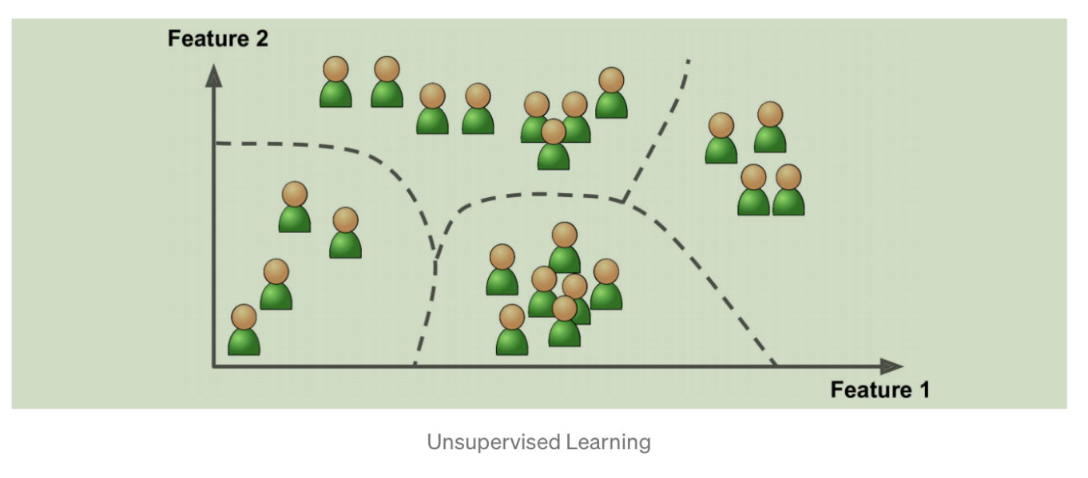

## ****Semi-supervised Learning :-****

→ Some algorithm can deal with partially labeled training set, usually a lots of unlabeled data and little labeled data. This is know as semi-supervised learning.

*→ Google Photos* is a good example of this, where it automatically recognize same person and if we label that person in one of the picture, system will automatically label others photos in which he/she is there.

## ****Reinforcement Learning :-****

→ Reinforcement learning is all different. In this system learns by observing environment, select and performs action and get *rewards* or *penalties* in form of negative rewards. System must learn by itself what is best strategy know as *policy.*A policy defines what action to take when it is in a given situation.

→ DeepMind’s Alpha Go is good example of Reinforcement learning. Note that learning was turned off during the game, Alpha Go was just applying policy it had learned.

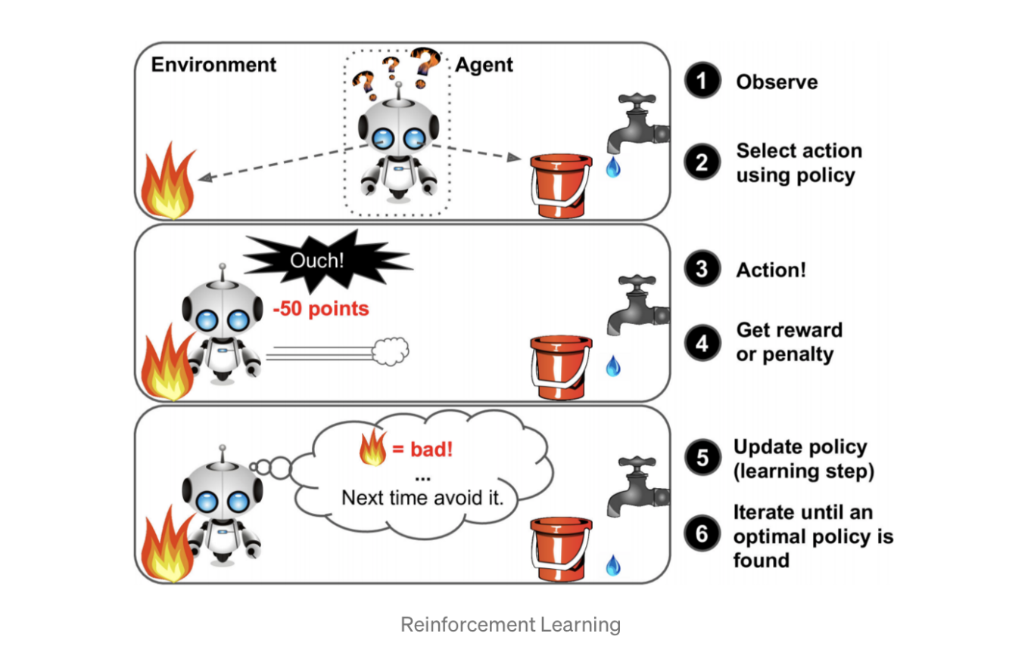

## ****Batch Learning :-****

→ In batch learning, first system is trained then it is used in live action and runs without learning anymore, it applies what it has learned. This is also know as *offline learning*. If we want to train system on new data then we have to train new version of system from scratch and then train on old as well as new training data.

→ It may take many hours to train new system, so typically we train new system every 24 hour or weekly. Also, training on full sets of data requires lots of computational power (memory space, CPU, disk I/O, network I/O, disk space).If amount of data is huge, it may be impossible to use batch learning algorithm.

## ****Online Learning :-****

→ In online learning, we train the system incrementally by feeding new sample data sequentially, either individually or by small groups (mini-batch). Each learning step is fast and computational cheap, so system will learn about new data simultaneously, as it arrives. Here we can train a system that predicts stock prices, which may change simultaneously as new data arrives.

→ Online learning algorithm can also be used to train system on huge datasets which cannot fit into one machine’s main memory. This is called as out-of-core learning. The algorithm loads part of data, train on it and repeat the process until it runs on all of the data.

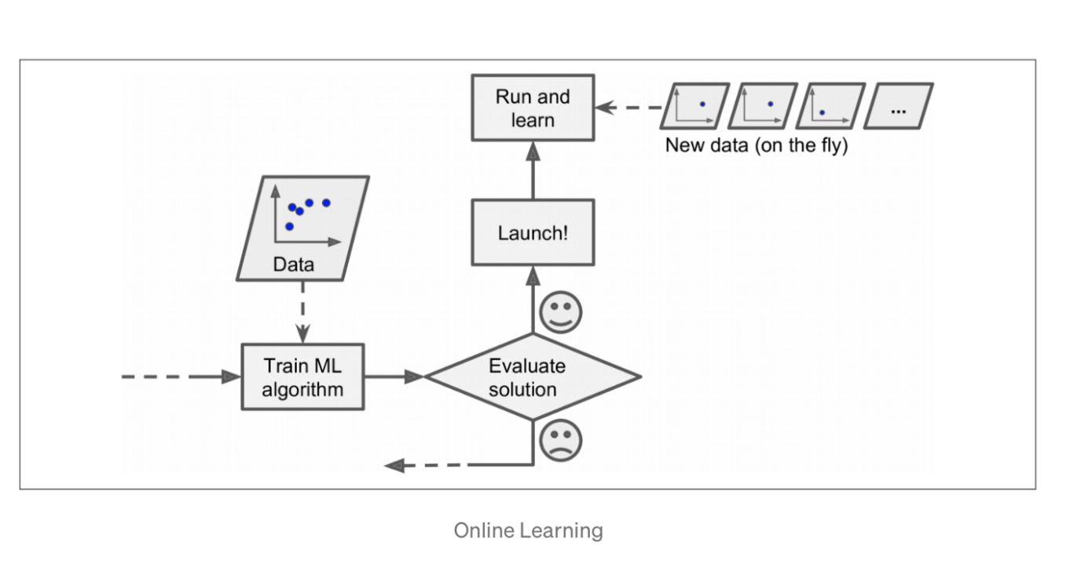

## ****Instance-based Learning :-****

→ Possibly the most trivial way of learning would be to learn by heart. If we want to create a spam filter, simply mark emails as spam which are similar to spam emails marked by user itself.

→ In Instance-based learning, system learns examples by heart and then generalizes to new cases by comparing to the learned examples, using a similarity measure.

## ****Model-based Learning :-****

→ Another way to generalize from a set of examples is to build a model of these examples and then use this model to make prediction. This is know as model-based learning.

→For example, if we had built a system that differentiates between triangle and square and if new instance arrives then model will predict whether it is triangle or square.

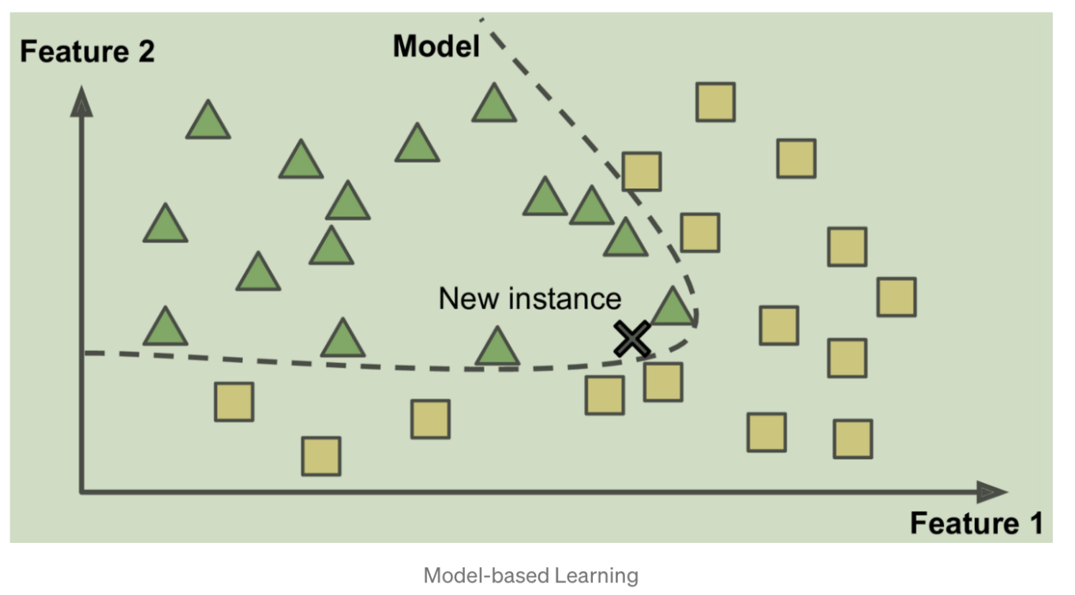

Contact Links :-

Twitter : https://twitter.com/jasanidarsh3

LinkedIn: https://www.linkedin.com/in/darsh-jasani

Github: https://github.com/darshjasani